Steps For Run the code

1. Path = C:\Users\radhi\PycharmProjects\pythonProject

You can navigate this path and delete csv file for run the code



Delete this csv file if available



1. Open pycharm application

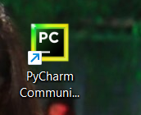

1. Display main code run the code using this green button

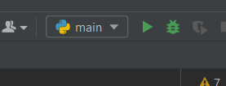

1. After automatically camera ON Then you can open 1 image on mobile screen and show the camera

1) ratan tata

2) nikola tesla

3) stive jobs

Browse any one image on mobile if detected then open second image and then stop using

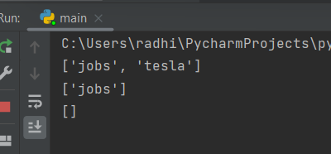

Detected successfully then

1. stop red then

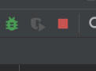

1. After automatically system generate one csv attendance file on this folder so you can again navigate this path and open csv file attendances mark successfully



Open csv file on excel

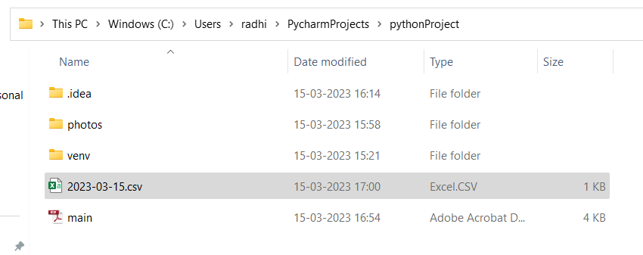

Attendance entry successfully with time and date

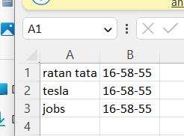

Date is on csv file name format

#-----------------------------------------------done--------------------------------------------------------------#

You can also add your photo on Photos folder but also added little bit code on { main.py } python file

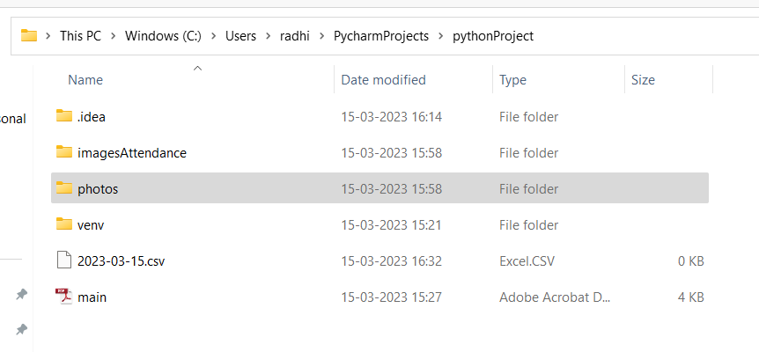

#--------------------------------------------packages----------------------------------------------------------------------------

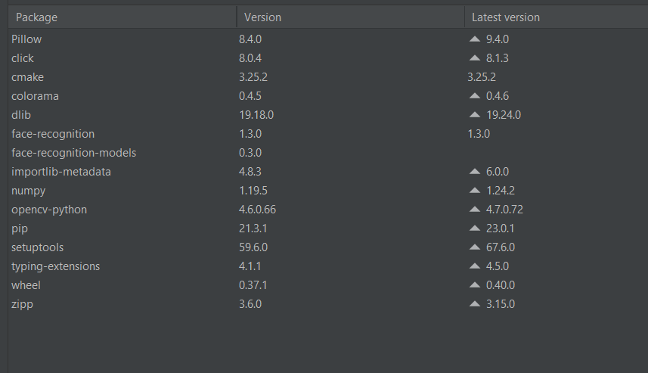

#----------------------------------------------------------------------------------------------------------------------------------

How to add packages

file ------ settings ------python interpreter ------- (+) plus button

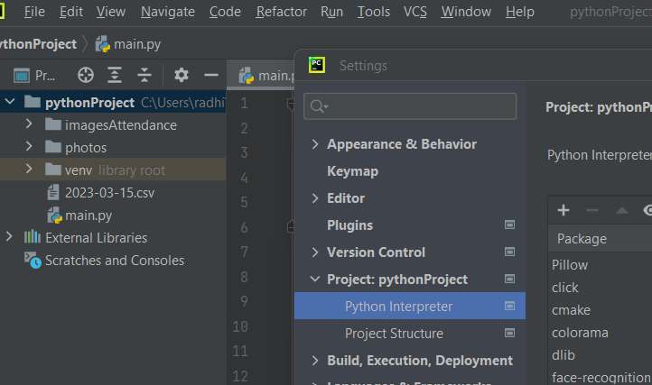

Python version 3.6.0

